Become Water Wise Today!
Try the following Water Wise tips (indoor & outdoor) and start saving water today, then take the Shrink your Water Footprint Challenge and send us your results.
Cleaning Products – Home and Personal
Using “green” or “biodegradable” soaps, shampoos, laundry and dish detergents and cleaning products reduce the number of harmful chemicals that you are sending down the drain and introducing to the environment. Choose products that are phosphate-free (causes harmful algal blooms), bleach-free (a lung irritant), petroleum-free (oil is not necessary for cleaning) and biodegradable. If a product is covered in warnings, steer clear.
Most every store has a line of “alternative” products that you can choose from. Or make your own home cleaning and laundry products using basics such as baking soda, vinegar and Borax. Google “natural, non-toxic cleaning products” for ideas.
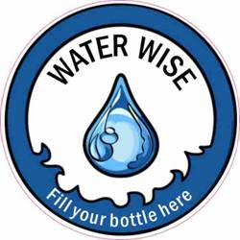
Tap to Bottle
If you are out for a walk or shopping and run out of water, rather than buying a bottle of water, look for business windows that display a Tap to Bottle sticker. You can take your reusable water bottle into a participating business and refill your water bottle with water. Tap to Bottle is a network of businesses in our community that are willing to provide access to water and welcome community members to come in and refill their reusable water bottles (no additional purchases are expected). Keep an eye out for the Tap to Bottle sticker on display in the front window or door of local businesses. Contact the Conservation Society if your office or business would like to join the Tap to Bottle campaign.
Golden Lawns Campaign
Residents are encouraged to let their lawns go “golden” and “natural.” The lawns are “green” when Mother Nature waters them, “golden” when the weather gets hot and dry. They are also herbicide and pesticide free. Natural lawns protect our rivers and streams from pollution and protect the City’s groundwater aquifer by conserving precious drinking water. The Conservation Society has creative signs painted by local children that can be posted on your “golden lawn” to encourage neighbours and friends to do the same.
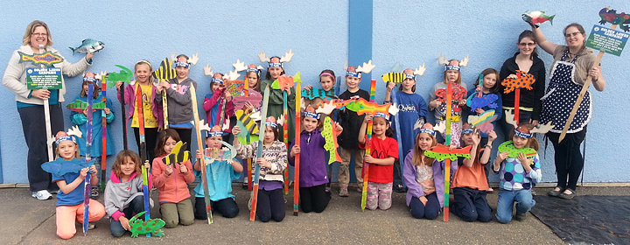
Golden lawns signs painted by Brownies and Guides
Down the Drain: Storm Drain Sandwich Boards
Art with a message. Watch for sandwich boards with an artistic touch around the community. Local elementary and high school students have created colourful depictions of “life at the end of a storm drain.” The art reminds residents that that what flows down a storm drain ends up in our rivers and streams and that “only rain should go down the drain.” Garbage, pet waste, chemicals, oil and other pollutants do not belong in storm drains. Remember, if you wouldn’t want to swim in or drink it, neither would the fish and wildlife.
