Become Waste Wise Today
We put our waste in a bag and send it away. But where is away? A landfill. They take up valuable space in our landscape, are expensive to operate and can pollute our environment. When we really look at what we throw away, we can see that most of our garbage is not really garbage at all, but rather reusable, recyclable and compostable materials. Only a small part of our garbage is “really” garbage (non-recyclable, not reusable, not repairable or compostable).
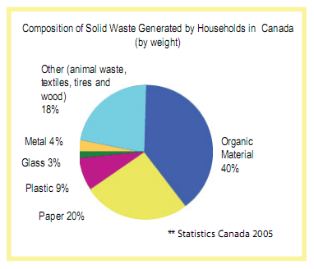
Let's make less waste! Fortunately, it is easy to reduce the amount of garbage we create by making everyday choices that take responsibility for the waste we produce – at home, at school, at the office, at work, when shopping – every little bit helps! By following the 6 R's: Rethink, Refuse, Repair, Reduce, Reuse, Recycle and Composting; we can help make a difference in our environment and expand the life of our landfills, the life of the products we use and our quality of life!

